Rakamin SQL BigQuery

**Rating cabang**

SELECT

    branch_id,

    branch_category,

    branch_name,

    kota,

    provinsi,

    rating AS rating_cabang

FROM

    `kimia_farma.kf_kantor_cabang`

ORDER BY

    rating_cabang DESC;

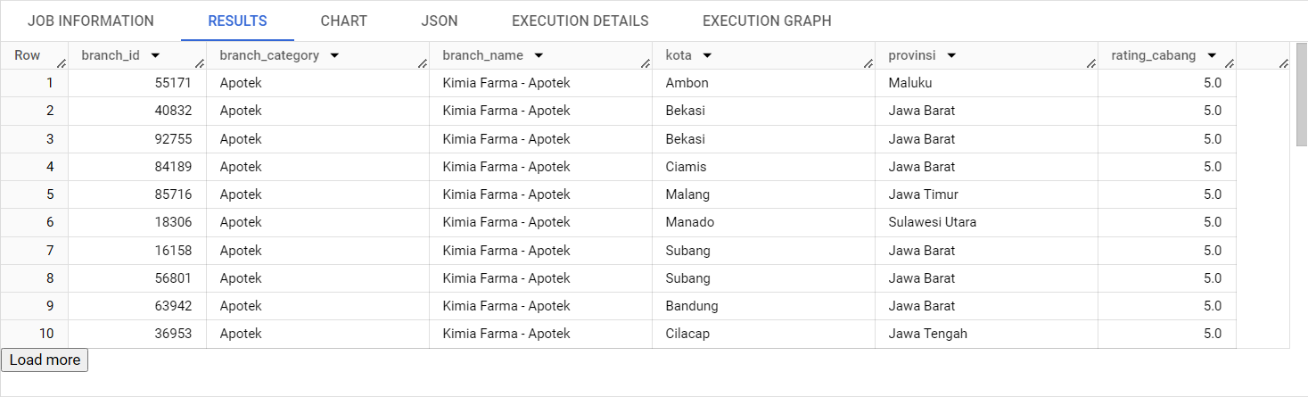

**Customer_name**

SELECT

transaction_id,

 customer_name,

 product_id,

 price

FROM

    `kimia_farma.kf_final_transaction`

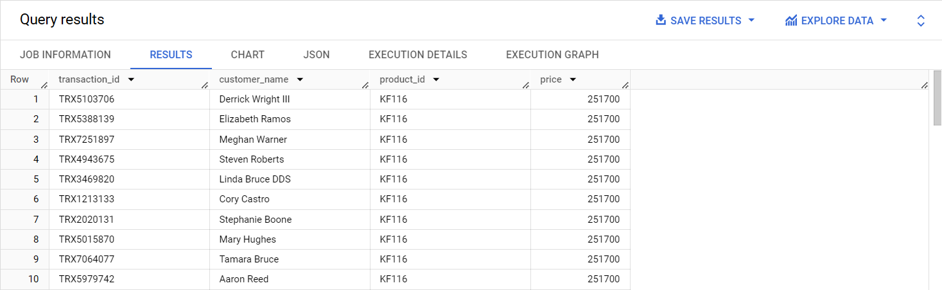

**Product_id dan product_name**

SELECT

    product_id,

    product_name

FROM

    `kimia_farma.kf_inventory`

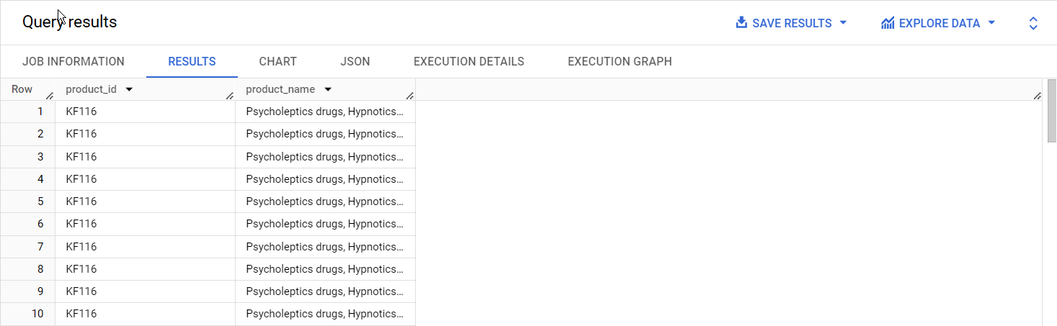

**Actual_price**

SELECT

    product_id,

    product_name,

    price AS actual_price

FROM

    `kimia_farma.kf_product`

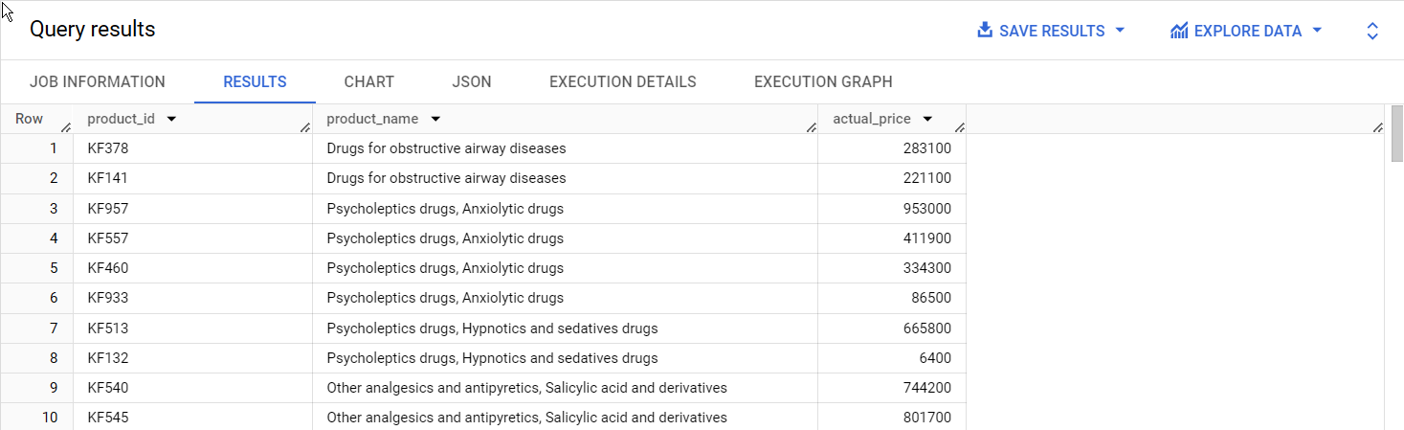

**Discount_percentage**

SELECT

    transaction_id,

    customer_name,

    product_id,

    discount_percentage

FROM

    `kimia_farma.kf_final_transaction`

WHERE

    discount_percentage > 0.1;

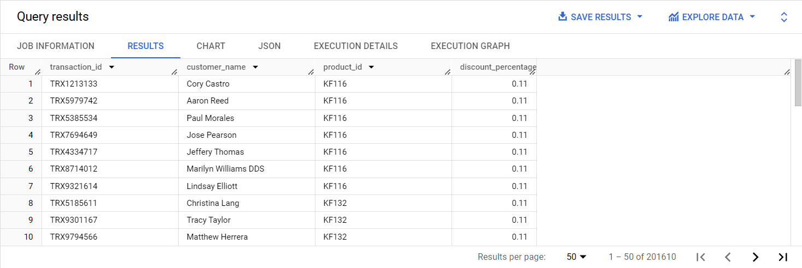

**Persentase_gross_laba**

SELECT

    transaction_id,

    date,

    branch_id,

    customer_name,

    product_id,

    price,

    discount_percentage,

    rating,

    CASE

        WHEN price <= 50000 THEN '10%'

        WHEN price > 50000 AND price <= 100000 THEN '15%'

        WHEN price > 100000 AND price <= 300000 THEN '20%'

        WHEN price > 300000 AND price <= 500000 THEN '25%'

        WHEN price > 500000 THEN '30%'

    END AS persentase_gross_laba

FROM

    `kimia_farma.kf_final_transaction`

WHERE

    price > 50000;

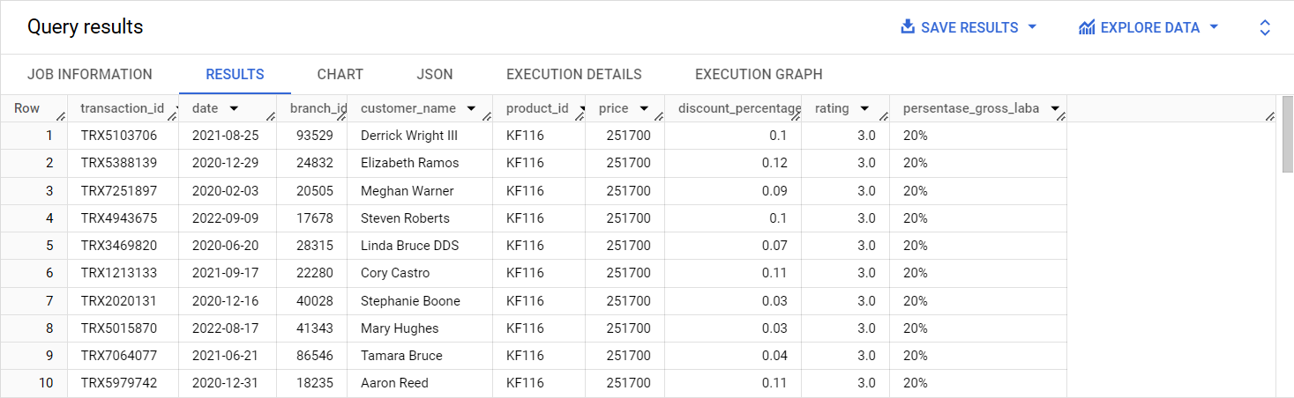

**Nett_sales**

SELECT

    transaction_id,

    customer_name,

    product_id,

    price,

    discount_percentage,

    CASE

        WHEN price <= 50000 THEN 0.10

        WHEN price > 50000 AND price <= 100000 THEN 0.15

        WHEN price > 100000 AND price <= 300000 THEN 0.20

        WHEN price > 300000 AND price <= 500000 THEN 0.25

        ELSE 0.30

    END AS persentase_gross_laba,

    price * (1 - discount_percentage) AS nett_sales

FROM

    `kimia_farma.kf_final_transaction`

WHERE

    price > 50000;

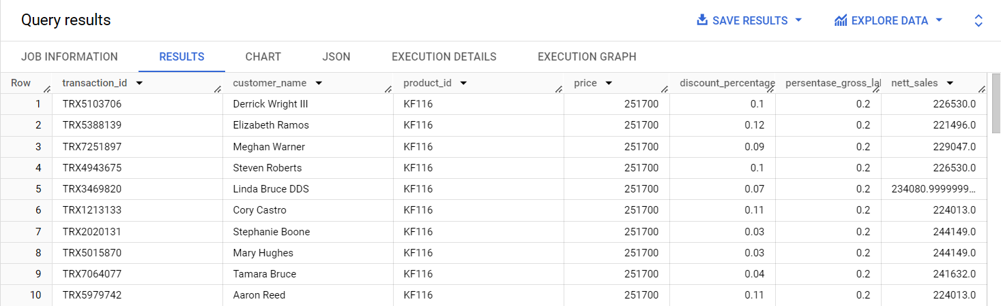

**Nett_profit**

SELECT

    transaction_id,

    customer_name,

    product_id,

    price,

    discount_percentage,

    CASE

        WHEN price <= 50000 THEN 0.10

        WHEN price > 50000 AND price <= 100000 THEN 0.15

        WHEN price > 100000 AND price <= 300000 THEN 0.20

        WHEN price > 300000 AND price <= 500000 THEN 0.25

        ELSE 0.30

    END AS persentase_gross_laba,

    price * (1 - discount_percentage) AS net_sales,

    (price * (1 - discount_percentage)) *

    CASE

        WHEN price <= 50000 THEN 0.10

        WHEN price > 50000 AND price <= 100000 THEN 0.15

        WHEN price > 100000 AND price <= 300000 THEN 0.20

        WHEN price > 300000 AND price <= 500000 THEN 0.25

        ELSE 0.30

    END AS nett_profit

FROM

    `kimia_farma.kf_final_transaction`

WHERE

    price > 50000;

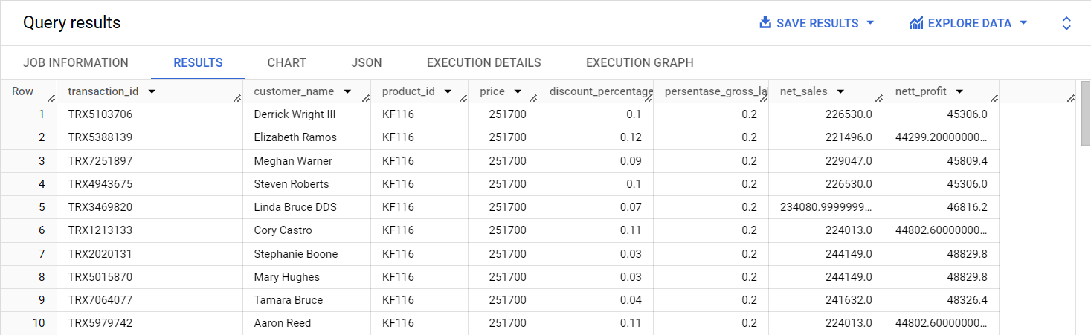

**Rating_transaksi**

SELECT

    transaction_id,

    date,

    branch_id,

    customer_name,

    product_id,

    price,

    discount_percentage,

    rating,

    CASE

        WHEN price <= 50000 THEN 0.10

        WHEN price > 50000 AND price <= 100000 THEN 0.15

        WHEN price > 100000 AND price <= 300000 THEN 0.20

        WHEN price > 300000 AND price <= 500000 THEN 0.25

        ELSE 0.30

    END AS persentase_gross_laba,

    price * (1 - discount_percentage) AS net_sales,

    (price * (1 - discount_percentage)) *

    CASE

        WHEN price <= 50000 THEN 0.10

        WHEN price > 50000 AND price <= 100000 THEN 0.15

        WHEN price > 100000 AND price <= 300000 THEN 0.20

        WHEN price > 300000 AND price <= 500000 THEN 0.25

        ELSE 0.30

    END AS nett_profit,

    CASE

        WHEN rating >= 4.5 THEN 'Excellent'

        WHEN rating >= 3.5 THEN 'Good'

        WHEN rating >= 2.5 THEN 'Average'

        WHEN rating >= 1.5 THEN 'Below Average'

        ELSE 'Poor'

    END AS rating_transaksi

FROM

    `kimia_farma.kf_final_transaction`

WHERE

    price > 50000;

